

Adwait Purao - 2021300101 TE Comps B - Batch B

DC LAB

**DISTRIBUTED COMPUTING EXPERIMENT 9**

**Aim:**

Implementation of a Client Server based program to check data consistency.

**Theory:**

Client-Server Architecture:

Client-Server Model:

The client-server architecture is a common paradigm in distributed systems where tasks are divided between clients and servers. Clients request services or resources, and servers provide those services or resources. In the context of an inventory management system, clients can request operations like adding items, removing items, or checking the inventory status.

Inventory Management System:

Basic Operations:

Adding Items (ADD): Clients can add items to the inventory with a specified quantity.

Removing Items (REMOVE): Clients can remove items from the inventory, ensuring data consistency.

Viewing Inventory Status (STATUS): Clients can check the current status of the inventory.

Characteristics:

Communication: Clients and servers communicate over a network, typically using protocols such as TCP/IP.

Decentralized Processing: Clients and servers operate independently, allowing for better scalability and distribution of computational load.

Resource Sharing: Servers provide shared resources and services to multiple clients.

Data Consistency in Distributed Systems:

Definition:

Data consistency in distributed systems refers to the uniformity and accuracy of shared data across multiple nodes. Maintaining consistency becomes challenging due to factors such as network latency, node failures, and the need for synchronization among distributed entities.

Challenges:

Concurrency: Coordinating concurrent access to shared resources to prevent conflicts.

Fault Tolerance: Ensuring data consistency in the presence of node failures.

Scalability: Balancing the trade-off between consistency and system scalability.

Consistency Models:

Strong Consistency: Guarantees that all nodes see the same data at the same time.

Eventual Consistency: Allows for temporary inconsistencies but guarantees convergence over time.

Causal Consistency: Preserves causal relationships between related operations.

Consistency Protocols:

Two-Phase Commit (2PC): Coordinates the commit or rollback of transactions across distributed nodes.

Quorum-Based Systems: Decision-making based on a majority vote or agreement among a subset of nodes.

Vector Clocks: Tracking causality in distributed systems for partial ordering of events.

Code Relevance:

The provided code exemplifies a basic client-server system for an inventory management application. Key aspects related to distributed computing and data consistency in the code include:

Client-Server Interaction: The code implements a simple client-server communication model where the client sends requests, and the server processes and responds to those requests.

Data Consistency Checks: The server code includes basic data consistency checks during operations like adding and removing items from the inventory. This addresses the challenge of ensuring accurate updates to shared data.

Concurrency Control: While the code doesn't explicitly implement advanced concurrency control, it lays the foundation for understanding how such mechanisms could be integrated in a distributed environment.

**Code:**

Server.py

import socket

inventory = {}

def add_item(product_id, product_name, quantity):

if product_id in inventory:

inventory[product_id]['quantity'] += quantity

else:

inventory[product_id] = {'product_name': product_name, 'quantity': quantity}

def remove_item(product_id, quantity):

if product_id in inventory and inventory[product_id]['quantity'] >= quantity:

inventory[product_id]['quantity'] -= quantity

return True # Indicate consistency

else:

print(f"Error: Inconsistent data. Not enough {inventory.get(product_id, {}).get('product_name')} in the inventory.")

return False # Indicate inconsistency

def get_inventory_status():

return inventory

def handle_client_request(request):

command, *params = request.split()

if command == "ADD":

product_id, product_name, quantity = params

add_item(product_id, product_name, int(quantity))

return "Item added to inventory."

elif command == "REMOVE":

product_id, quantity = params

consistency_check_passed = remove_item(product_id, int(quantity))

return f"Item removed from inventory." if consistency_check_passed else "Error: Inconsistent data."

elif command == "STATUS":

return str(get_inventory_status())

else:

return "Invalid command. Supported commands: ADD, REMOVE, STATUS"

def start_server():

server_socket = socket.socket(socket.AF_INET, socket.SOCK_STREAM)

server_address = ('localhost', 12345)

print(f"Starting server on {server_address[0]}:{server_address[1]}")

server_socket.bind(server_address)

server_socket.listen(1)

while True:

print("Waiting for a connection...")

client_socket, client_address = server_socket.accept()

print(f"Accepted connection from {client_address}")

request = client_socket.recv(1024).decode('utf-8')

print(f"Received request: {request}")

response = handle_client_request(request)

print(f"Data consistency check: {response}")

client_socket.send(str(response).encode('utf-8'))

client_socket.close()

print("Connection closed\n")

if __name__ == "__main__":

start_server()

Client.py

import socket

def send_request_to_server(request):

client_socket = socket.socket(socket.AF_INET, socket.SOCK_STREAM)

server_address = ('localhost', 12345)

client_socket.connect(server_address)

print(f"Sending request to server: {request}")

client_socket.send(request.encode('utf-8'))

response = client_socket.recv(1024).decode('utf-8')

print(f"Server response: {response}")

client_socket.close()

if __name__ == "__main__":

while True:

print("1. Add item to inventory")

print("2. Remove item from inventory")

print("3. View detailed inventory status")

print("4. Exit")

choice = input("Enter your choice (1-4): ")

if choice == "1":

product_id = input("Enter product ID: ")

product_name = input("Enter product name: ")

quantity = int(input("Enter quantity: "))

send_request_to_server(f"ADD {product_id} {product_name} {quantity}")

elif choice == "2":

product_id = input("Enter product ID: ")

quantity = int(input("Enter quantity: "))

send_request_to_server(f"REMOVE {product_id} {quantity}")

elif choice == "3":

send_request_to_server("STATUS")

elif choice == "4":

print("Exiting the program.")

break

else:

print("Invalid choice. Please enter a number between 1 and 4.")

**Output:**

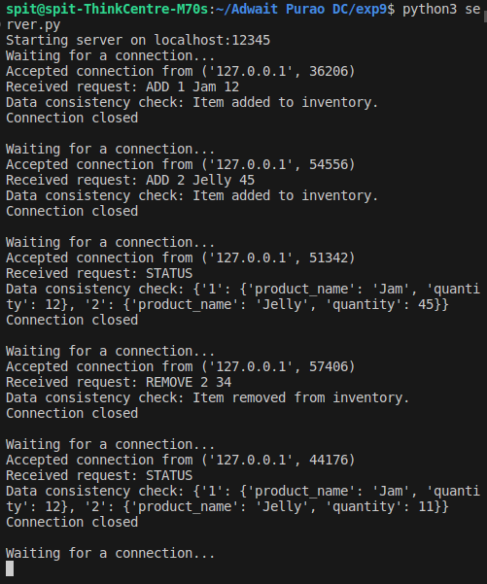

**Conclusion:**

In summary, the assignment introduced a client-server inventory management system in the context of distributed computing. The code demonstrates essential concepts like client-server interaction, data consistency checks, and basic concurrency control. It provides a foundational understanding, encouraging further exploration into advanced distributed computing topics, such as consensus algorithms and fault tolerance. This assignment serves as a starting point for practical application and extension based on specific distributed computing requirements.